SINGLE STREAM RECYCLING
You no longer have to spend time sorting your recyclable materials into separate bins. Beginning immediately, you may begin placing your recyclables in your 96 gallon recycle container for easy curbside collection.
All recyclable material will be collected EVERY OTHER THURSDAY
What to INCLUDE in Recycling Containers:

*Newspapers, Magazines, Catalogs *Cardboard-flattened *Mixed Paper/ Office Paper
*Telephone/Soft Cover Books *Junk/Bulk Mail *Empty aerosol cans
*Metal Cans (tin, steel, aluminum) *Brown Paper Bags
*Aluminum (pie plates, trays, foil) *Corrugated Cardboard Flattened
*Paperboard (cereal box, shoe boxes)
*Paper milk/juice cartons (no foil pouches, DO NOT flatten

**WE DO NOT ACCEPT THE FOLLOWING MATERIALS**
***PLASTICS of any kind (#1-7) will NO LONGER BE ACCEPTED for curbside recycling ***

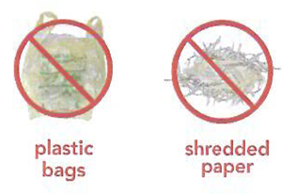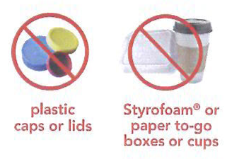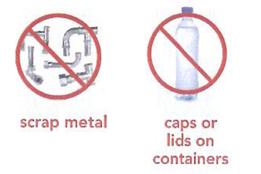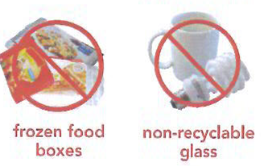
C&C DISPOSAL Pueblo West RECYCLING CALENDAR 2020
RECYCLING PICK UP DAYS ARE SHADED
JANUARY |  |  |  |  |  |  | FEBRUARY |  |  |  |  |  |  | MARCH
S | M | T | W | T | F | S | S | M | T | W | T | F | S | S | M | T | W | T |  | F | S
 |  |  | 1 | 2 | 3 | 4 |  |  |  |  |  |  | 1 | 1 | 2 | 3 | 4 | 5 |  | 6 | 7
5 | 6 | 7 | 8 | 9 | 10 | 11 | 2 | 3 | 4 | 5 | 6 | 7 | 8 | 8 | 9 | 10 | 11 | 12 |  | 13 | 14
12 | 13 | 14 | 15 | 16 | 17 | 18 | 9 | 10 | 11 | 12 | 13 | 14 | 15 | 15 | 16 | 17 | 18 | 19 |  | 20 | 21
19 | 20 | 21 | 22 | 23 | 24 | 25 | 16 | 17 | 18 | 19 | 20 | 21 | 22 | 22 | 23 | 24 | 25 | 26 |  | 27 | 28
26 | 27 | 28 | 29 | 30 | 31 |  | 23 | 24 | 25 | 26 | 27 | 28 | 29 | 29 | 30 | 31
APRIL |  |  |  |  |  |  | MAY |  |  |  |  |  |  |  |  | JUNE
S | M | T | W | T | F | S | S | M | T | W | T | F | S | S | M | T | W | T | F |  | S
 |  |  | 1 | 2 | 3 | 4 |  |  |  |  |  | 1 | 2 |  | 1 | 2 | 3 | 4 | 5 |  | 6
5 | 6 | 7 | 8 | 9 | 10 | 11 | 3 | 4 | 5 | 6 | 7 | 8 | 9 | 7 | 8 | 9 | 10 | 11 | 12 |  | 13
12 | 13 | 14 | 15 | 16 | 17 | 18 | 10 | 11 | 12 | 13 | 14 | 15 | 16 | 14 | 15 | 16 | 17 | 18 | 19 |  | 20
19 | 20 | 21 | 22 | 23 | 24 | 25 | 17 | 18 | 19 | 20 | 21 | 22 | 23 | 21 | 22 | 23 | 24 | 25 | 26 |  | 27
26 | 27 | 28 | 29 | 30 |  |  | 24 | 25 | 26 | 27 | 28 | 29 | 30 | 28 | 29 | 30
 |  |  |  |  |  |  | 31
JULY |  |  |  |  |  |  | AUGUST |  |  |  |  |  |  | SEPTEMBER
S | M | T | W | T | F | S | S | M | T | W | T | F | S | S | M | T | W | T |  | F | S
 |  |  | 1 | 2 | 3 | 4 |  |  |  |  |  |  | 1 |  |  | 1 | 2 | 3 |  | 4 | 5
5 | 6 | 7 | 8 | 9 | 10 | 11 | 2 | 3 | 4 | 5 | 6 | 7 | 8 | 6 | 7 | 8 | 9 | 10 |  | 11 | 12
12 | 13 | 14 | 15 | 16 | 17 | 18 | 9 | 10 | 11 | 12 | 13 | 14 | 15 | 13 | 14 | 15 | 16 | 17 |  | 18 | 19
19 | 20 | 21 | 22 | 23 | 24 | 25 | 16 | 17 | 18 | 19 | 20 | 21 | 22 | 20 | 21 | 22 | 23 | 24 |  | 25 | 26
26 | 27 | 28 | 29 | 30 | 21 |  | 23 | 24 | 25 | 26 | 27 | 28 | 29 | 27 | 28 | 29 | 30
 |  |  |  |  |  |  | 30 | 31
OCTOBER |  |  |  |  |  |  | NOVEMBER |  |  |  |  |  |  | DECEMBER
S | M | T | W | T | F | S | S | M | T | W | T | F | S | S | M | T | W | T |  | F | S
 |  |  |  | 1 | 2 | 3 | 1 | 2 | 3 | 4 | 5 | 6 | 7 |  |  | 1 | 2 | 3 |  | 4 | 5
4 | 5 | 6 | 7 | 8 | 9 | 10 | 8 | 9 | 10 | 11 | 12 | 13 | 14 | 6 | 7 | 8 | 9 | 10 |  | 11 | 12
11 | 12 | 13 | 14 | 15 | 16 | 17 | 15 | 16 | 17 | 18 | 19 | 20 | 21 | 13 | 14 | 15 | 16 | 17 |  | 18 | 19
18 | 90 | 20 | 21 | 22 | 23 | 24 | 22 | 23 | 24 | 25 | 26 | 27 | 28 | 20 | 21 | 22 | 23 | 24 |  | 25 | 26
25 | 26 | 27 | 28 | 29 | 30 | 31 | 29 | 30 |  |  |  |  |  | 27 | 28 | 29 | 30 | 31
REGULAR SCHEDULE Holiday Schedule
Recycling is collected every other Thursday Collection may result in a one day delay if a holiday lands on any weekday.

Ph 719-647-9100 fax 719-546-7925
P.O. Box 14 Pueblo, CO 81002
C&C Disposal would like to welcome you!

Following is some important information about your new service:

Your pick-up day will be
Thursday
HOLIDAY SCHEDULE – NO RECYCLE REMOVAL ON:
New Year’s Day Labor Day
Memorial Day Thanksgiving
July 4th Christmas

- The above holidays will result in a one day delay of collection when they land on a weekday.
- Plastic (all plastic) is NOT ALLOWED with recycle service
- Recyclables must be put out by 5 AM or the night before your pick up day to ensure removal. If trash is not out, return trips are not guaranteed and will be assessed a $10 return fee.
- We will not pick up contaminated recyclables. If your recyclables are contaminated they will not be picked up until allowable materials are in your container. Please note, a contamination fee may apply if applicable.
- Loss or damage to the container provided will result in an $80 replacement fee.
- Late fees will apply to all accounts past due. Accounts that have been suspended due to nonpayment must pay the account in full to restart service. No credits will be applied for service not provided during this time.
- A $10 delivery fee will apply for both container removal & re-delivery whether it is due to a cancellation or service reinstatement.
- Please mail your payment with your account number included to the address listed on your invoice. If paying by check, please be aware that any payment returned for non-sufficient funds, will result in a $40.00 fee. Also, for your convenience, we accept VISA, MasterCard, and Discover in office, by phone or on the web. Please visit our website at www.pueblorecycle.com

Thank you for your business! We look forward to serving you for many years to come!

